Free School Meals Eligibility Check
Dear Parent/Carer

Re: Free School Meals – Important Information

From the start of the 2026/27 academic year, all children from households in receipt of Universal Credit will be entitled to receive a Free School Meal.
To check if you are eligible for Free School Meals go to:
https://fsm.lgfl.net/app/school/17504 (further details on following pages).
There will be two categories of benefits-based Free School Meals as follows:
- Targeted FSM: This will continue to be based on the existing threshold, covering children who are in households in receipt of Universal Credit with annual household earnings of £7,400 or less. In addition to receiving free meals, children eligible for targeted FSM, will attract Pupil Premium and other disadvantage funding for their schools.

- Expanded FSM: This is a new category covering children who do not qualify for targeted FSM, but who are in households receiving Universal Credit. Children eligible for Expanded FSM will be entitled to a free meal only.

Transition protection, which has been in effect since 1 April 2018, will end in July 2026. From the start of the 2026/27 academic year, children will have to meet the eligibility criteria for FSM to continue receiving this provision. Eligibility for free meals will be kept under regular review through regular rechecks. This means that some children currently protected may no longer qualify unless they meet the new eligibility rules at the point of checking.
From the start of the 2026/27 academic year, Free School Meals will be available to children in receipt of, or whose parents are in receipt of, one or more of the following benefits:
- Universal Credit.
- Support under Part VI of the Immigration and Asylum Act 1999.
- Income-related Employment and Support Allowance.
- Receive the guarantee element of Pension Credit.
- Meet the criteria set out in separate guidance for families with no recourse to public funds.

Eligibility criteria for Free School Meals:
To check if you are eligible for Free School Meals go to:
https://fsm.lgfl.net/app/school/17504

Select the local authority and school
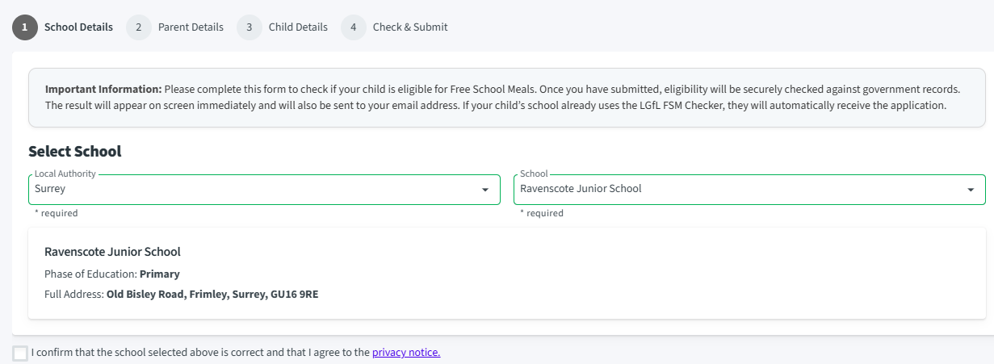
To access your account, you will need the details below:
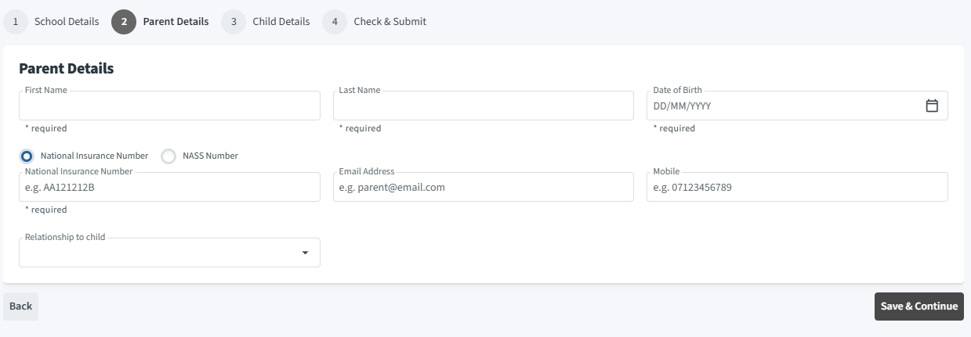

You will then need to add your child’s details and submit the details to check eligibility.
The check will come back to you confirming if you are eligible or not. You will be given a code if eligible which should be forwarded on to info@ravenscote.surrey.sch.uk to update our records.
This service is free and you can check or recheck at any time should your circumstances change.
If you have any questions or need help with the application, please do not hesitate to contact our school office at info@ravenscote.surrey.sch.uk

