Pupil Premium and Free School Meals Check

Free School Meals Eligibility Check

The eligibility for Free School Meals generates necessary funding for the school once your child is registered.
If you think that your child may qualify for Free School Meals, it is important that you use this checker. This is not dependent on your child having meals.
The Free School Meal Checking Service is a simple online process where parents can determine eligibility for free school meals, which in turn may attract the extra funding for each of their children’s schools. Parents are not required to accept free meals but schools appreciate the help with conducting an online check.
How it works for parents:
After entering a few details into the website, the online application process links to the Department for Education database and gives an immediate ‘yes’ or ‘no’ response.
This system is designed to eliminate the need to apply in person for free school meals and improve the claims process for schools. It also means that if you are eligible for free meals, the school is able to process your application using the information you submit.
There is no need to re-apply each year, as schools can recheck eligibility as required using the data already provided - although if your child moves to a different school then you will need to update your account.
In addition, the following pupils will be protected against losing their free school meals as follows:
- From 1 April 2018, all existing free school meals claimants will continue to receive free school meals whilst Universal Credit is rolled out. This will apply even if their earnings rise above the new threshold during that time.
- In addition, any child gaining eligibility for free school meals after 1 April 2018 will be protected against losing free school meals during the Universal Credit rollout period.
- Once Universal Credit is fully rolled out, any existing claimants that no longer meet the eligibility criteria at that point (because they are earning above the threshold or are no longer a recipient of Universal Credit) will continue to receive free school meals until the end of their current phase of education (i.e. primary or secondary).

Eligibility criteria for Free School Meals:
Does either parent /carer receive any of the following
Income Support
income-based Jobseeker’s Allowance
income-related Employment and Support Allowance
support under Part VI of the Immigration and Asylum Act 1999
the guaranteed element of Pension Credit
Child Tax Credit (provided you’re not also entitled to Working Tax Credit and have an annual gross income of no more than £16,190)
Working Tax Credit run-on - paid for 4 weeks after you stop qualifying for Working Tax Credit
Universal Credit - if you apply on or after 1 April 2018 your household income must be less than £7,400 a year (after tax and not including any benefits you get)
To check if you are eligible for Free School Meals go to:
https://pps.lgfl.org.uk/
Click on the Check eligibility button

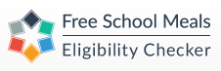
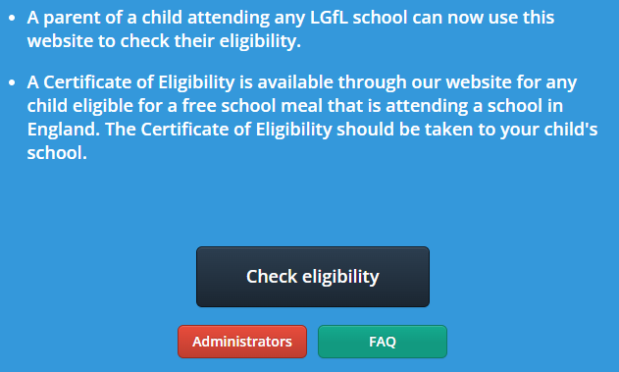
All parents should already have an account (this is the same system you used to apply for a school place for your child) so either select “return to your account” or “forgotten your username/password”. The system will tell you if you do not already have an account and then you will need to choose the “create a new account” option.

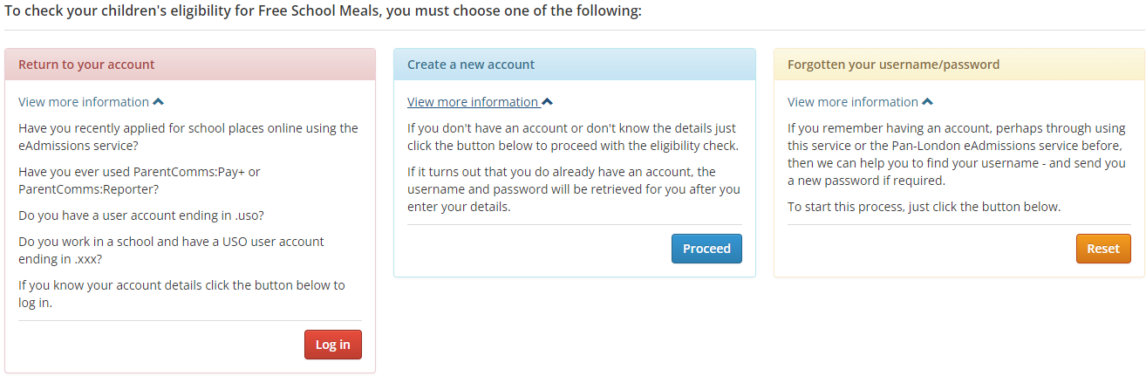
Once you have access to your account you will need your National Insurance Number along with date of birth and current address.
The check will come back to you confirming if you are eligible or not. The school will receive notification if you are eligible so our records can be updated.

Pupil Premium Eligibility Check
The eligibility for Pupil Premium generates necessary funding for the school once your child is registered.
Eligibility criteria for Pupil Premium:
- Has your child ceased to be looked after by the local authority, a special guardianship order, a child arrangement order or a residence order
- Is your child a looked- after Child (LAC) i.e. in the care of, or provided with accommodation by an English authority
- Are either or both parents’ regular members of HM forces and designated as personal category 1 or 2, in the armed forces of another nation and stationed in England, or in receipt of a child pension from the ministry of defence

DECLARATION:

I confirm that the details supplied are correct.
By signing this form, I am confirming that I have read and fully understood the above declaration.

Signed:……………………………………………………………………

Date:………………………………………………………………………………

All replies will be kept strictly confidential.

PLEASE RETURN THIS FORM TO info@ravenscote.surrey.sch.uk

